epochs = 1

comms_round = 10

fraction_fit=0.8

fraction_evaluate=0.5,

**FedAvg**

|  |  |  |  |  |  |  |  |  |  |  |  |
| --- | --- | --- | --- | --- | --- | --- | --- | --- | --- | --- | --- |
|  | %non-iid = 0 | 10 | 20 | 30 | 40 | 50 | 60 | 70 | 80 | 90 | 100 |
| Acc | 0.9702 | 0.9707 | 0.9699 | 0.9635 | 0.9689 | 0.9559 | 0.9561 | 0.9514 | 0.9169 | 0.3103 | 0.2067 |
| Precision | 0.9703 | 0.9707 | 0.9997 | 0.9636 | 0.9690 | 0.9568 | 0.9566 | 0.9514 | 0.9180 | 0.9927 | 0.9188 |
| Recall | 0.9702 | 0.9707 | 0.9699 | 0.9635 | 0.9689 | 0.9559 | 0.9561 | 0.9514 | 0.9169 | 0.3103 | 0.2067 |
| F1-Score | 0.9702 | 0.9707 | 0.9699 | 0.9635 | 0.9689 | 0.9560 | 0.9561 | 0.9514 | 0.9168 | 0.3770 | 0.2837 |

**FedImp -gốc**

|  |  |  |  |  |  |  |  |  |  |  |  |
| --- | --- | --- | --- | --- | --- | --- | --- | --- | --- | --- | --- |
|  | %non-iid = 0 | 10 | 20 | 30 | 40 | 50 | 60 | 70 | 80 | 90 | 100 |
| Acc | 0.9695 | 0.9691 | 0.9706 | 0.9698 | 0.9644 | 0.9647 | 0.956 | 0.9471 | 0.9271 | 0.3399 | 0.2108 |
| Precision | 0.9695 | 0.9694 | 0.9706 | 0.9699 | 0.9644 | 0.9647 | 0.956 | 0.9471 | 0.9279 | 0.9450 | 0.9947 |
| Recall | 0.9695 | 0.9691 | 0.9706 | 0.9698 | 0.9644 | 0.9647 | 0.956 | 0.9471 | 0.9271 | 0.3399 | 0.2108 |
| F1-Score | 0.9695 | 0.9691 | 0.9706 | 0.9698 | 0.9644 | 0.9647 | 0.956 | 0.9471 | 0.9272 | 0.4041 | 0.3019 |

**FedImpJSD**

|  |  |  |  |  |  |  |  |  |  |  |  |
| --- | --- | --- | --- | --- | --- | --- | --- | --- | --- | --- | --- |
|  | %non-iid = 0 | 10 | 20 | 30 | 40 | 50 | 60 | 70 | 80 | 90 | 100 |
| Acc | 0.9678 |  |  |  |  | 0.9602 |  |  |  | 0.3413 |  |
| Precision | 0.9680 |  |  |  |  | 0.9868 |  |  |  | 0.999 |  |
| Recall | 0.9678 |  |  |  |  | 0.9602 |  |  |  | 0.3413 |  |
| F1-Score | 0.9678 |  |  |  |  | 0.9602 |  |  |  | 0.4201 |  |

**50 rounds huấn luyện**

* **%non-iid: 0%**

**FedImpJSD**

|  |  |  |  |  |  |  |  |  |  |  |  |
| --- | --- | --- | --- | --- | --- | --- | --- | --- | --- | --- | --- |
|  | %non-iid = 0 | 10 | 20 | 30 | 40 | 50 | 60 | 70 | 80 | 90 | 100 |
| Acc | 0.988 |  |  |  |  | 0.9843 |  |  |  | 0.7047 |  |
| Precision | 0.9880 |  |  |  |  | 0.9843 |  |  |  | 0.998 |  |
| Recall | 0.988 |  |  |  |  | 0.9843 |  |  |  | 0.7047 |  |
| F1-Score | 0.9880 |  |  |  |  | 0.9843 |  |  |  | 0.7184 |  |

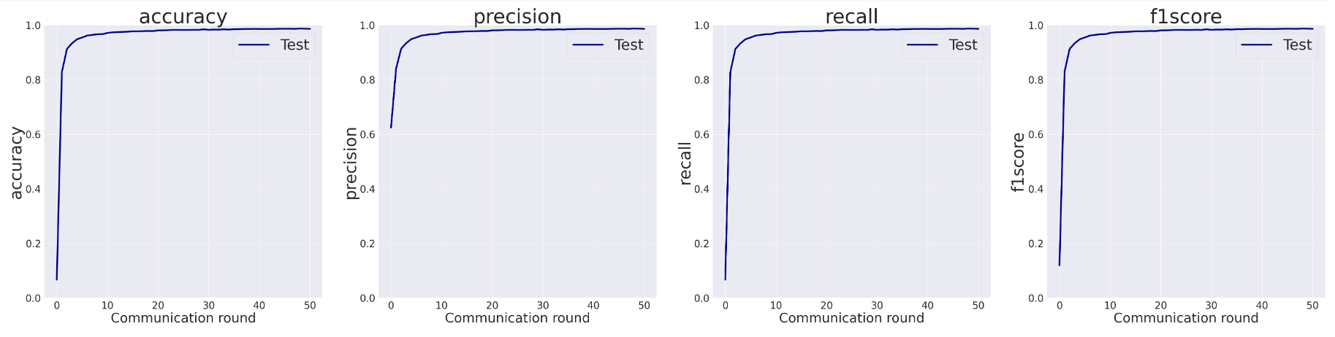

[(0, 0.0673), (1, 0.8279), (2, 0.9132), (3, 0.9337), (4, 0.9488), (5, 0.9552), (6, 0.9621), (7, 0.9649), (8, 0.9667), (9, 0.9675), (10, 0.9717), (11, 0.9742), (12, 0.9749), (13, 0.9756), (14, 0.9763), (15, 0.9776), (16, 0.9779), (17, 0.9784), (18, 0.9792), (19, 0.9788), (20, 0.9812), (21, 0.9813), (22, 0.9819), (23, 0.9831), (24, 0.9832), (25, 0.9828), (26, 0.9828), (27, 0.9835), (28, 0.9831), (29, 0.9852), (30, 0.9834), (31, 0.9843), (32, 0.9841), (33, 0.9851), (34, 0.9843), (35, 0.9855), (36, 0.9855), (37, 0.9862), (38, 0.9863), (39, 0.9866), (40, 0.9863), (41, 0.9862), (42, 0.9862), (43, 0.9864), (44, 0.987), (45, 0.9872), (46, 0.9871), (47, 0.9867), (48, 0.988), (49, 0.9874), (50, 0.9868)]

**FedAvg**

|  |  |  |  |  |  |  |  |  |  |  |  |
| --- | --- | --- | --- | --- | --- | --- | --- | --- | --- | --- | --- |
|  | %non-iid = 0 | 10 | 20 | 30 | 40 | 50 | 60 | 70 | 80 | 90 | 100 |
| Acc | 0.987 |  |  |  |  | 0.9844 |  |  |  | 0.7832 |  |
| Precision | 0.987 |  |  |  |  | 0.9844 |  |  |  | 0.8324 |  |
| Recall | 0.987 |  |  |  |  | 0.9844 |  |  |  | 0.7832 |  |
| F1-Score | 0.987 |  |  |  |  | 0.9844 |  |  |  | 0.7861 |  |

[(0, 0.1197), (1, 0.8835), (2, 0.9217), (3, 0.9403), (4, 0.9515), (5, 0.9594), (6, 0.9604), (7, 0.9658), (8, 0.9694), (9, 0.971), (10, 0.9712), (11, 0.9749), (12, 0.9758), (13, 0.9763), (14, 0.9771), (15, 0.9785), (16, 0.9784), (17, 0.978), (18, 0.9802), (19, 0.9806), (20, 0.9808), (21, 0.9812), (22, 0.9819), (23, 0.9816), (24, 0.9813), (25, 0.9825), (26, 0.9821), (27, 0.9819), (28, 0.9831), (29, 0.9841), (30, 0.9838), (31, 0.9843), (32, 0.9843), (33, 0.984), (34, 0.9855), (35, 0.9856), (36, 0.9852), (37, 0.9844), (38, 0.9857), (39, 0.9855), (40, 0.9858), (41, 0.9866), (42, 0.9864), (43, 0.9865), (44, 0.987), (45, 0.987), (46, 0.9863), (47, 0.9861), (48, 0.986), (49, 0.987), (50, 0.9869)]

**FedImp gốc**

|  |  |  |  |  |  |  |  |  |  |  |  |
| --- | --- | --- | --- | --- | --- | --- | --- | --- | --- | --- | --- |
|  | %non-iid = 0 | 10 | 20 | 30 | 40 | 50 | 60 | 70 | 80 | 90 | 100 |
| Acc |  |  |  |  |  |  |  |  |  | 0.7002 |  |
| Precision |  |  |  |  |  |  |  |  |  | 0.9759 |  |
| Recall |  |  |  |  |  |  |  |  |  | 0.7002 |  |
| F1-Score |  |  |  |  |  |  |  |  |  | 0.7187 |  |

* **%non-iid: 50%**

**FedImpJSD**

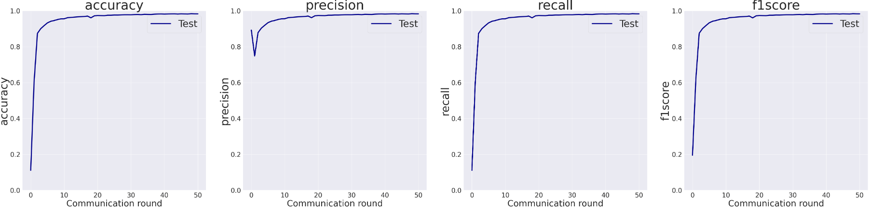

[(0, 0.1113), (1, 0.6026), (2, 0.8747), (3, 0.9009), (4, 0.9176), (5, 0.9331), (6, 0.9419), (7, 0.9461), (8, 0.9514), (9, 0.9555), (10, 0.9558), (11, 0.9618), (12, 0.9633), (13, 0.965), (14, 0.9665), (15, 0.9676), (16, 0.9687), (17, 0.9709), (18, 0.9612), (19, 0.9719), (20, 0.9742), (21, 0.9736), (22, 0.9732), (23, 0.9757), (24, 0.9757), (25, 0.9766), (26, 0.9765), (27, 0.9771), (28, 0.9782), (29, 0.9783), (30, 0.9781), (31, 0.9794), (32, 0.98), (33, 0.9788), (34, 0.9807), (35, 0.9802), (36, 0.9799), (37, 0.9814), (38, 0.9822), (39, 0.9825), (40, 0.9819), (41, 0.9824), (42, 0.9832), (43, 0.9834), (44, 0.982), (45, 0.9835), (46, 0.9827), (47, 0.9822), (48, 0.9843), (49, 0.9835), (50, 0.9833)]

**FedAvg**

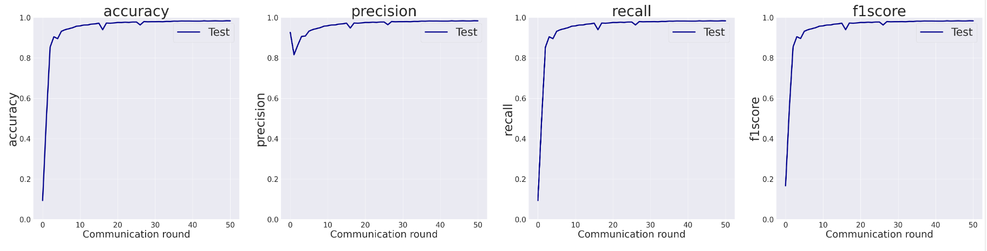

[(0, 0.0942), (1, 0.498), (2, 0.8539), (3, 0.9051), (4, 0.8958), (5, 0.9323), (6, 0.9402), (7, 0.9449), (8, 0.95), (9, 0.9573), (10, 0.9593), (11, 0.9632), (12, 0.9639), (13, 0.9676), (14, 0.9694), (15, 0.9721), (16, 0.9402), (17, 0.9731), (18, 0.9718), (19, 0.9738), (20, 0.9759), (21, 0.9757), (22, 0.977), (23, 0.976), (24, 0.9782), (25, 0.9783), (26, 0.9638), (27, 0.9803), (28, 0.9794), (29, 0.9798), (30, 0.9798), (31, 0.9801), (32, 0.9796), (33, 0.981), (34, 0.9807), (35, 0.9824), (36, 0.982), (37, 0.9834), (38, 0.983), (39, 0.9831), (40, 0.9826), (41, 0.9824), (42, 0.9824), (43, 0.9841), (44, 0.983), (45, 0.9836), (46, 0.9841), (47, 0.9835), (48, 0.9834), (49, 0.9844), (50, 0.9841)]

* **%non-iid: 90%**

**FedImpJSD**

[(0, 0.1362), (1, 0.1567), (2, 0.0967), (3, 0.2076), (4, 0.2354), (5, 0.2139), (6, 0.2397), (7, 0.2428), (8, 0.254), (9, 0.3062), (10, 0.3194), (11, 0.2594), (12, 0.2032), (13, 0.3358), (14, 0.3838), (15, 0.3115), (16, 0.3699), (17, 0.4413), (18, 0.3769), (19, 0.4061), (20, 0.4058), (21, 0.4425), (22, 0.4895), (23, 0.5248), (24, 0.4946), (25, 0.4957), (26, 0.5157), (27, 0.5299), (28, 0.5331), (29, 0.5993), (30, 0.51), (31, 0.5531), (32, 0.5652), (33, 0.595), (34, 0.5832), (35, 0.599), (36, 0.6175), (37, 0.6079), (38, 0.638), (39, 0.6366), (40, 0.6062), (41, 0.6486), (42, 0.6354), (43, 0.6319), (44, 0.7047), (45, 0.6993), (46, 0.6896), (47, 0.7039), (48, 0.6762), (49, 0.6838), (50, 0.6851)]

**FedAvg**

[(0, 0.1573), (1, 0.1729), (2, 0.1846), (3, 0.1882), (4, 0.2229), (5, 0.3158), (6, 0.2697), (7, 0.2884), (8, 0.3073), (9, 0.2676), (10, 0.362), (11, 0.3756), (12, 0.4232), (13, 0.4336), (14, 0.4507), (15, 0.4207), (16, 0.4435), (17, 0.4204), (18, 0.3961), (19, 0.4384), (20, 0.4449), (21, 0.5109), (22, 0.4868), (23, 0.5563), (24, 0.57), (25, 0.5928), (26, 0.6393), (27, 0.5642), (28, 0.6094), (29, 0.5678), (30, 0.595), (31, 0.6727), (32, 0.6673), (33, 0.6914), (34, 0.6503), (35, 0.6566), (36, 0.6997), (37, 0.6928), (38, 0.7336), (39, 0.6911), (40, 0.6891), (41, 0.6786), (42, 0.7564), (43, 0.7252), (44, 0.7163), (45, 0.7108), (46, 0.7694), (47, 0.7579), (48, 0.7613), (49, 0.7695), (50, 0.7832)]

**FedImp gốc**

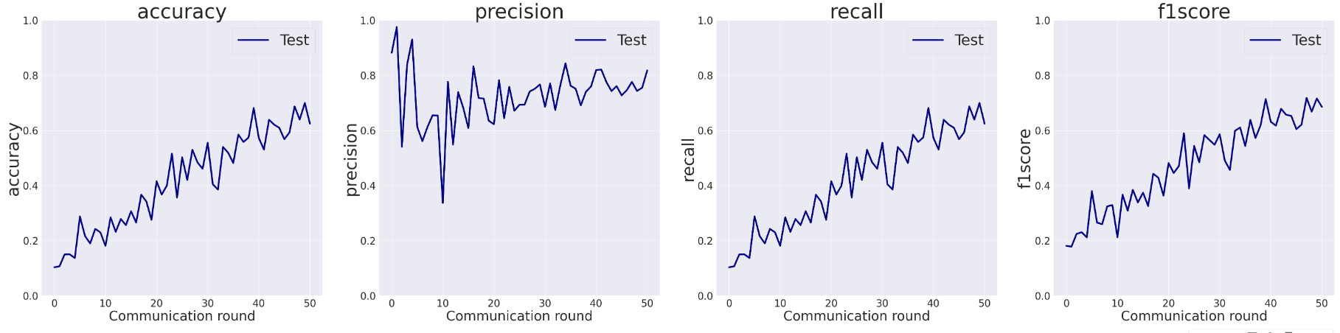

[(0, 0.1039), (1, 0.1072), (2, 0.1503), (3, 0.1508), (4, 0.1373), (5, 0.2882), (6, 0.217), (7, 0.1904), (8, 0.2432), (9, 0.2305), (10, 0.1815), (11, 0.285), (12, 0.2323), (13, 0.279), (14, 0.2569), (15, 0.3072), (16, 0.2662), (17, 0.3671), (18, 0.3426), (19, 0.2762), (20, 0.4159), (21, 0.3678), (22, 0.4001), (23, 0.5162), (24, 0.3566), (25, 0.5032), (26, 0.4206), (27, 0.5301), (28, 0.4846), (29, 0.4612), (30, 0.5559), (31, 0.405), (32, 0.3859), (33, 0.5403), (34, 0.5196), (35, 0.4822), (36, 0.5854), (37, 0.5586), (38, 0.575), (39, 0.6819), (40, 0.573), (41, 0.5313), (42, 0.6394), (43, 0.6215), (44, 0.6101), (45, 0.5685), (46, 0.5934), (47, 0.6877), (48, 0.64), (49, 0.7002), (50, 0.6252)]